TFS #99449

Soft Errors Firing for Location Panel for Deleted Collateral

Kevin Geissler

11/23/2016

Table of Contents

TFS # 1

Description 2

Testing Notes 2

Screen Shots and Steps Taken 2

# Description

KPG 11/23/16 - Discovered internally by Paul Marseglia. The soft error for Real Property Collateral not having a Primary Location selected is firing for deleted collateral. [Video](https://extranet.financialpartners.com/Workspaces/Shared/cwenhance/FPIDocuments/2016%20Q4%20TFS%20Testing%20Docs/Location%20Panel%20INC/Business%20Rules%20for%20Deleted%20Collateral.wmv). Appears to be happening on all deleted Real Estate.

# Testing Notes

## Screen Shots and Steps Taken

1. Deleted Real Estate Collateral

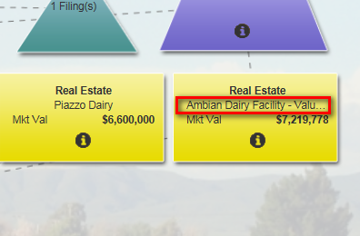

1. Deleted collateral is not showing up as a soft error upon submit.



